# Spatial and phylogenetic assessment of biofilms in microbial fuel cells

By

FORREST RYAN DOWDY

B.A. (University of North Carolina at Chapel Hill) 2010

DISSERTATION

Submitted in partial satisfaction of the requirements for the degree of

DOCTOR of PHILOSOPHY

In

Food Science

in the

OFFICE OF GRADUATE STUDIES

of the

UNIVERSITY OF CALIFORNIA

DAVIS

Approved:

____________________________________

Christopher W. Simmons, Chair

____________________________________

Jean S. VanderGheynst

____________________________________

Nitin Nitin

Committee in Charge

2018

# Abstract

Check out this figure in the appendix! (see Figure A.1).

Check out the olives (see Figure A.2).

# Dedication

# Contents

Spatial and phylogenetic assessment of biofilms in microbial fuel cells i

Abstract 1

Dedication 2

Contents 3

List of Tables 6

List of Figures 7

Chapter 1 Introduction 8

1.1 Background and Motivation 8

Chapter 2 Meta-analysis 10

2.1 Abstract 10

2.2 Introduction 10

2.3 Materials and Methods 10

2.4 Results 10

2.5 Discussion 10

2.6 Conclusion 10

Chapter 3 Performance of MFCs and Microbiome Analysis 11

3.1 Abstract 11

3.2 Introduction 11

3.3 Materials and Methods 11

3.4 Results 11

3.5 Discussion 11

3.6 Conclusion 11

Chapter 4 Characterization of biofilms formed 12

4.1 Abstract 12

4.2 Introduction 12

4.3 Materials and Methods 12

4.4 Results 12

4.5 Discussion 12

4.6 Conclusion 12

Chapter 5 Model creation and validation 13

5.1 Abstract 13

5.2 Introduction 13

5.3 Materials and Methods 13

5.4 Results 13

5.5 Discussion 13

5.6 Conclusion 13

Chapter 6 Concluding Remarks 14

Appendix A 15

Appendix B 15

Appendix C 15

References 17

# List of Tables

Table 1.1 Some stuff 8

# List of Figures

Figure 1.1 The NC State Wolf 8

**Appendix Figures**

Figure A.1 Easy Cheese 15

Figure A.2 Manzanilla Olives 15

# Introduction

## Background and Motivation

This is why I want to do this.



Figure 1.1 The NC State Wolf

Table 1.1 Some stuff

|  |  |  |  |
| --- | --- | --- | --- |
|  |  |  |  |
|  |  |  |  |

# Meta-analysis

## Abstract

## Introduction

## Materials and Methods

## Results

## Discussion

## Conclusion

# Performance of MFCs and Microbiome Analysis

## Abstract

## Introduction

## Materials and Methods

## Results

## Discussion

## Conclusion

# Characterization of biofilms formed

## Abstract

## Introduction

## Materials and Methods

## Results

## Discussion

## Conclusion

# Model creation and validation

## Abstract

## Introduction

## Materials and Methods

## Results

## Discussion

## Conclusion

# Concluding Remarks

###### 



Figure A.1 Easy Cheese

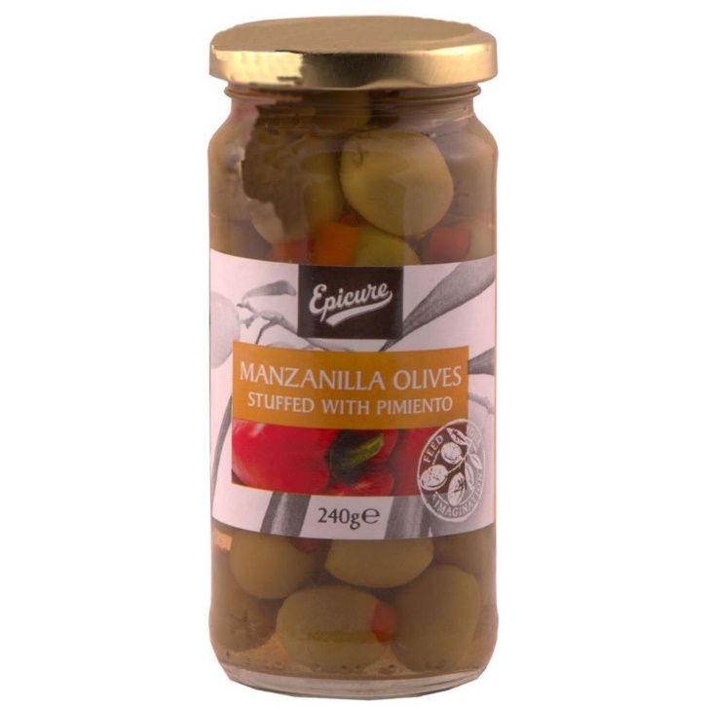

Figure A.2 Manzanilla Olives

###### 

###### 

# References

1. Sun, G., A. Thygesen, and A.S. Meyer, *Acetate is a superior substrate for microbial fuel cell initiation preceding bioethanol effluent utilization.* Appl Microbiol Biotechnol, 2015. **99**(11): p. 4905-15.